Department of Architecture contains five laboratories in a variety of computing activities, namely:
1-The Computer laboratory of Preliminary studies:
It is a scientific computer laboratory devoted to the study of preliminary computer studes for the fourth stages. The Laboratory consists of two parts, The theoretical part dedicated the theoretically lectures and the other part is dedicated to the practice of practical applications by students. The laboratory is provided with a number of desktop computers and the Device of Data Show which designated for that purpose.
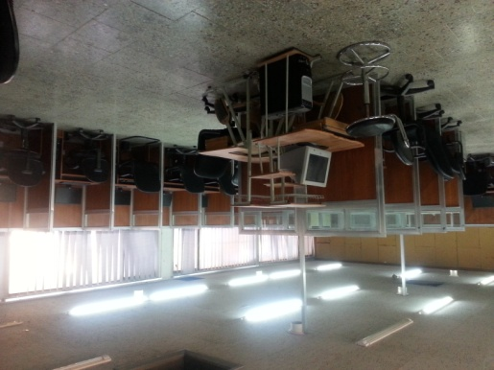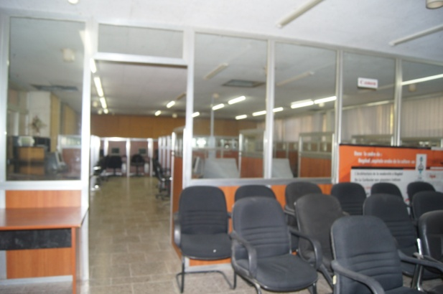

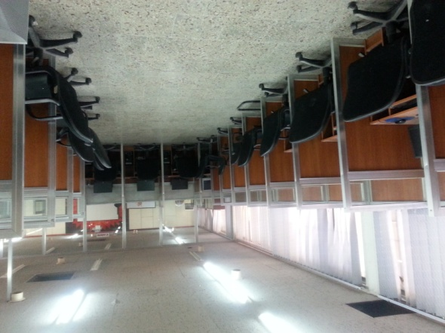
3-The laboratory of presentation:
It is one of the scientific laboratories dedicated to teaching the printing and displaying the architectural projects in deferent sizes. The laboratory is provided with a large format printers (tow Plotters) in in addition to the assisting tools and desktop computers.
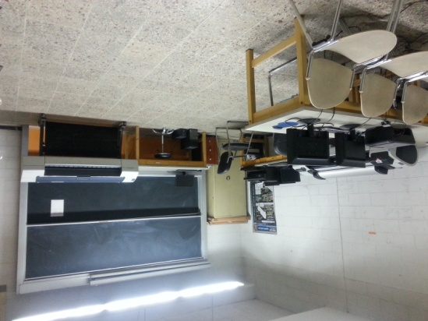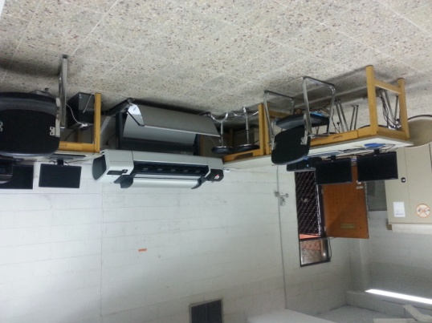

2-The Computer laboratory of post-graduate studies:
It is a scientific laboratory devoted to the study of post-graduate students . The laboratory is provided with a number of desktop computers and the Device of Data Show and the Overhead projectors and several assisting devias which designated for that purpose.
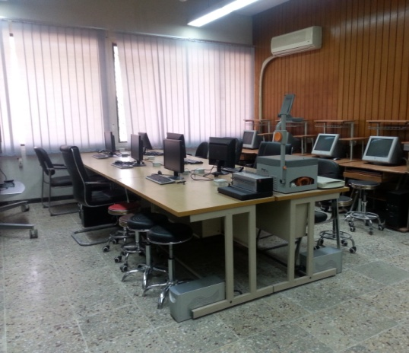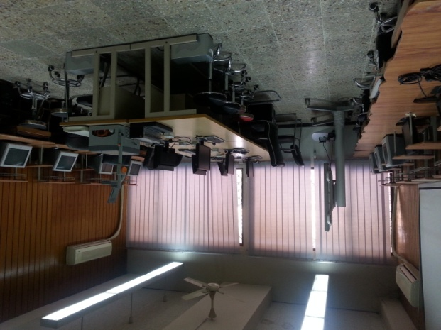

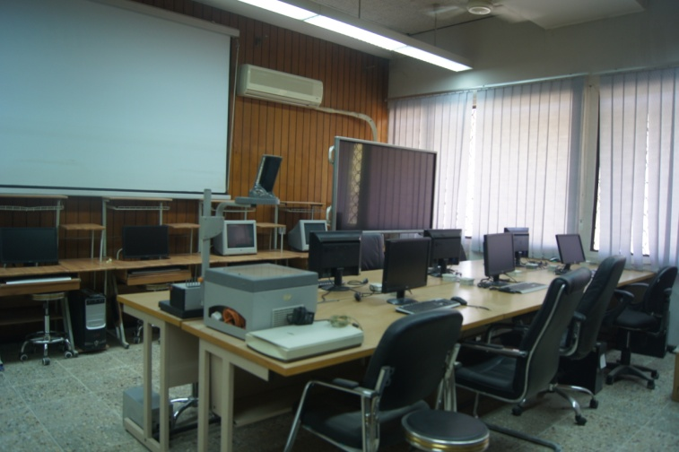

4-The Computer Interactive laboratory:
It is a modern laboratory, which was opened in the academic year 2013-2014 in the Department of Architecture, The laboratory is provided with smart-screen and a sophisticated computer system which emphasizes the principles of the interaction between the lectures and student through interactive communicating system of architectural programs and design in it.
5-The laboratory of acoustics:
It is a laboratory for the study of the acoustics in architecture, The laboratory is provided with a specialized system of audio and the technology which needed for testing and studies in the field of sound in architecture.

